
Chamber of Commerce
Business Development Centre
Market Buildings
St Peter Port GY1 1HE

Deputy de Saumarez
President Committee for Employment and Social Security
BY EMAIL: equality@gov.gg
Dear Deputy de Saumarez,
Subject: Consultation – Legislation to protect against age discrimination
I am writing on behalf of the Chamber of Commerce and our members in response to your request for feedback on the Consultation to introduce legislation to protect against age discrimination. We appreciate the opportunity to provide our input and suggestions on matters that are of vital importance to our local business community.
Firstly, we commend the Committee's commitment to seeking stakeholder feedback and ensuring that the voices of businesses are heard. With this in mind, we have reviewed the information shared and gathered insights from our members. Please note we received 49 survey responses, and our feedback is based on this data. We have over 450 members, approximately 80% of which is comprised of SMEs. However, larger businesses with over 26 employees made up over 40% of the respondents to this survey. Therefore, we consider that the survey responses came from a good cross-section of businesses.
On average, most of the respondents had at least one employee (that they were aware of) who is over the current States pension age, and an average of four employees aged 60 or over.

We have included a full set of the responses for your information, but we have also outlined their key concerns and areas of support below. We have also broken down our findings into the Parts A and B questions originally posed by the Committee in the consultation.

High level Commentary
These statistics support the overall sentiment that, while anti-discrimination measures are important and welcomed, businesses need practical flexibility to handle age-related employment issues in ways that are objective, clear, and manageable.
Prohibition of Age Discrimination in Employment:
88.10% agree that it should be unlawful to dismiss an employee purely due to their age unless such decision can be objectively justified, showing widespread support for incorporating age as a protected ground under the Ordinance.

Mandatory Retirement Age in contracts of employment:
58.70% of respondents believe employers should be able to set a compulsory retirement age, but only if they can objectively justify it. This indicates a majority support for keeping age-related retirement decisions in employment contracts flexible but tied to justification based on the specific job and business.

A smaller but still significant proportion (30.43%) expressed that compulsory retirement ages should never be allowed.
Objective Justification for Age-based Employment Decisions:
80.96% of respondents understand the concept of objective justification but 66.67% would want specific guidance and examples to better understand its application in practice. This suggests that while the concept is familiar, clear guidelines from the States would be helpful for the business community. Comments from the respondents showed a need for this guidance to be in plain English and easily understood.
Length of Service and Age Discrimination:
45.45% of respondents agree that employers should be able to use length of service to differentiate employee benefits up to 5 years. However, 54.55% believe that service-based differentiation should extend beyond five years or have no limitation at all, emphasising the importance of recognising long-term employee loyalty.

In terms of using seniority to determine pay or conditions, 41.30% of businesses confirmed they use seniority, showing that many employers still rely on this as a critical factor. Some respondents confirmed that their businesses base pay or conditions on job title and role rather than age or seniority. However, the reality is that seniority tends to correlate with job title/role, and it is therefore likely that this still shows employers rely on age or seniority in this way.
Retirement:
63.83% of respondents stated they do not have a contractual retirement age. This suggests flexibility already exists in many businesses, and most are willing to allow employees to work past traditional retirement ages if requested and deemed appropriate. These findings were supported by respondents who spoke about the need for flexibility on a case-by-case basis, how different industries will respond based on the role and how common it is to allow workers to continue working past retirement age.
Benefits and Healthcare:
55.56% of businesses do not limit private medical coverage based on age. However, for benefits like Permanent Health Insurance (PHI), 73.33% do not offer this benefit at all. For those that do offer it, only a select few limit it based on the employee's age or title. This demonstrates that some businesses still adjust benefits based on age but not the majority, presumably to control costs.

Similarly, 66.67% of businesses either do not offer occupational benefits or limit them by age, showing significant use of age-related distinctions in benefits.
Concerns about Over-regulation:
A number of respondents raised concerns about excessive regulation. One noted, "The last thing we need is more burdensome legislation," suggesting that, while fairness is valued, respondents are keen to ensure that the new laws do not cause unintended impacts on business flexibility.

Part A - RESPONSES

Part A considers proposed amendments to the Ordinance which involve the introduction of various statutory exceptions to unlawful discrimination on the protected ground of age.

- Do you agree that it should be unlawful to dismiss an employee due to their age unless this can be objectively justified?

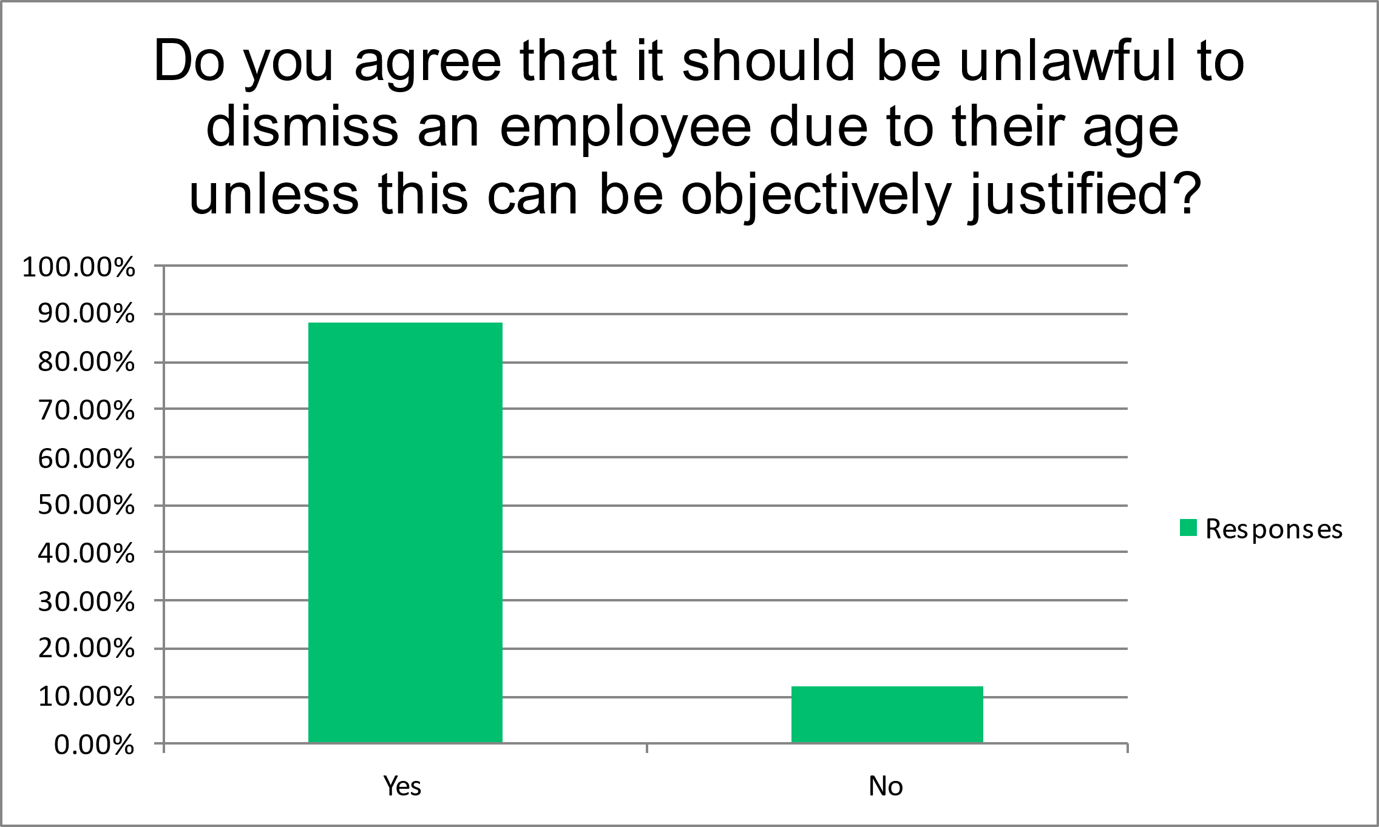

The graph above shows that 88.10% of respondents agree that it should be unlawful to dismiss an employee purely due to their age unless objectively justified, showing widespread support for anti-discrimination on the basis of age in employment practices. This is a strong mandate for including age as a protected ground under employment law. However, the Committee is also asked to note some comments from respondents which highlighted the possibility that some roles may be more physically demanding and more difficult to undertake with age, as well as that succession planning is important. For these reasons, respondents consider that exceptions to address circumstances of objective justification are needed.

Of the respondents, 42.86% worked as part of a pan-island, UK group or multi-national group company. Jersey and the UK already have age discrimination legislation in place and it would be helpful to these parties who cross these borders, if our legislation were to broadly follow what those jurisdictions have in place. Objective justification is a key part of the legislation of each of those jurisdictions.

- Do you think that a time-limited exception should be introduced so that employers would be permitted to lawfully dismiss employees who reach pensionable age for a limited period of time (e.g. two years)?

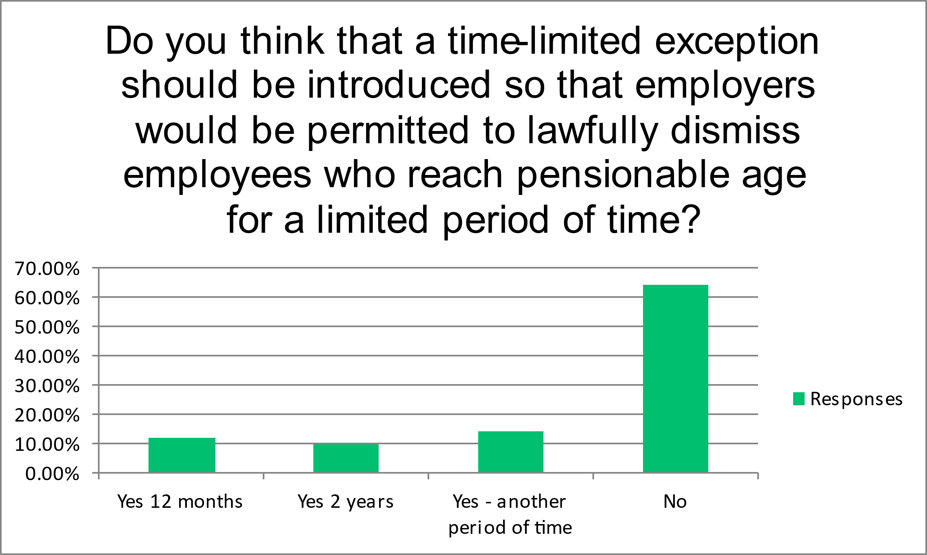

Over 64% of respondents answered no to this question but it generated a lot of comments – the most common highlighting the need for the changes to be well communicated, sufficient notice to prepare, and sufficient guidance and support being provided to employers. However, based on the comments received, we are slightly concerned that this aspect of the consultation may not have been as clear as needed. In particular, we consider that there appears to be a significant level of misunderstanding of the question, because most of the comments do not engage with the simple proposition (should there be a time-limited an exemption), but instead address other aspects which arise around about the issue of age discrimination more broadly. Thus the comments ranged from a desire for each situation to be assessed on a case-by-case basis and at the discretion of the employer, and that decisions should be made on fitness to continue working, capability of performance and health and safety, rather than solely on pensionable age. We therefore were not able to get an accurate answer to this question.

- Do you agree with the proposed list of exceptions?

Over half of the respondents indicated that they agreed with the proposed list of exceptions, however 39% agreed with some but not all of them. Commentary did not expand on specific exceptions that respondents did not agree with, save for a preference for compulsory retirement ages in employment contracts and a comment that young persons (age 16) should not be paid less than adults.

- Are there any exceptions which you would like to provide further comment on?

Other than a comment which focused on the need to ensure that benefits are offered on an equal basis to everyone irrespective of age, none of the respondents chose to provide further comments relevant to the exceptions listed. This suggests that the exceptions are generally reasonably well-understood and uncontroversial.

In order to look more closely at some of the proposed exceptions, we asked respondents about occupational benefits. 55.56% of respondents confirmed that their organisation provides private medical cover to all employees irrespective of age. 73.33% of respondents do not offer permanent health insurance. Of those who do, only 20% of respondents confirmed that it is offered as a benefit irrespective of age meaning that the majority of those who do offer this benefit do so using age criteria.

Other occupational benefits such as life assurance had similar findings, with 33.33% offering it to all employees irrespective of age, but 11.11% offering it to all but based on age criteria. Of those where age limits were imposed, the most common approach seemed to be that it was limited to those under state pension age and that the reason for this was down to the rules of the scheme or the service provider. We note that the use of age criteria in this respect is consistent with the other comparable jurisdictions to Guernsey, as they also permit organisations to use age-based criteria for occupational benefits. For this reason, we consider that adopting a comparable approach would support those businesses operating both within and outside of the Bailiwick and ensure that Bailiwick businesses are not adversely impacted as compared to our nearest competitors.

- Do you think there are any additional exceptions in relation to age which should be included in the Discrimination Ordinance? If so, please provide details.

Over 90% of respondents answered no, and of the comments made, the only additional exception proposed was that compulsory retirement ages in employment contracts should be allowed.

Part B

Part B considers the proposed amendment to the Ordinance which surrounds the introduction of the objective justification defence to claims of direct age discrimination.

- Do you agree or disagree with the Committee's position that objective justification should be a permitted defence in relation to complaints concerning direct discrimination on the grounds of age?

The significant majority of respondents (89%) are in support of objective justification and, further, from a business point of view, consider that it would be easier and more flexible for them to be able to assess the justification on a case-by-case basis rather than having to choose from a strict list of permitted exceptions only.

We asked our respondents whether they had an understanding of what objective justification means, with the government's definition provided at the beginning of the survey. 80.96% confirmed that they understood the meaning but 83.34% would like to see specific guidance explaining the concept of objective justification and giving worked examples. This fits with the thrust of the final comments on the survey which stress that, whilst age discrimination legislation is seen as a positive improvement, it needs to be clear to employers on what they are permitted to do, so that the change is not seen as a burdensome addition to HR and administration.

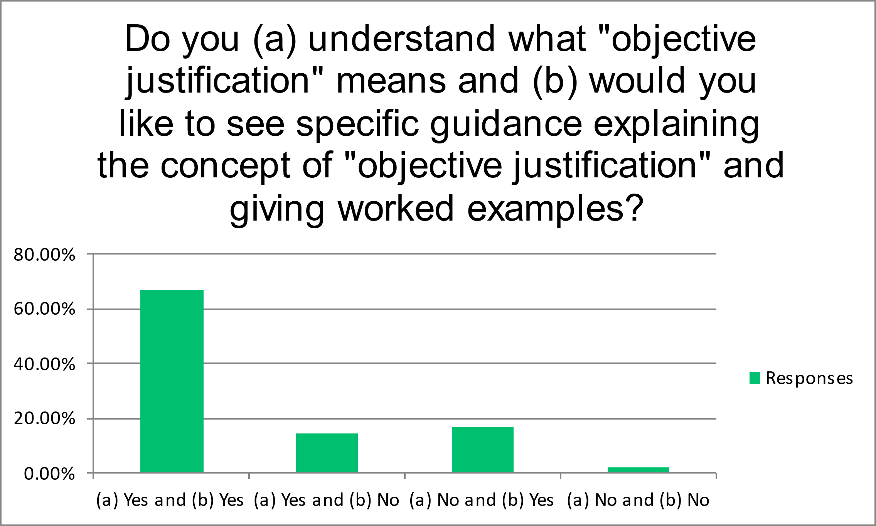

- The Committee's agreed position is that the legislation would provide protection from age discrimination for individuals of all ages in the context of employment. Do you agree or disagree with this position?

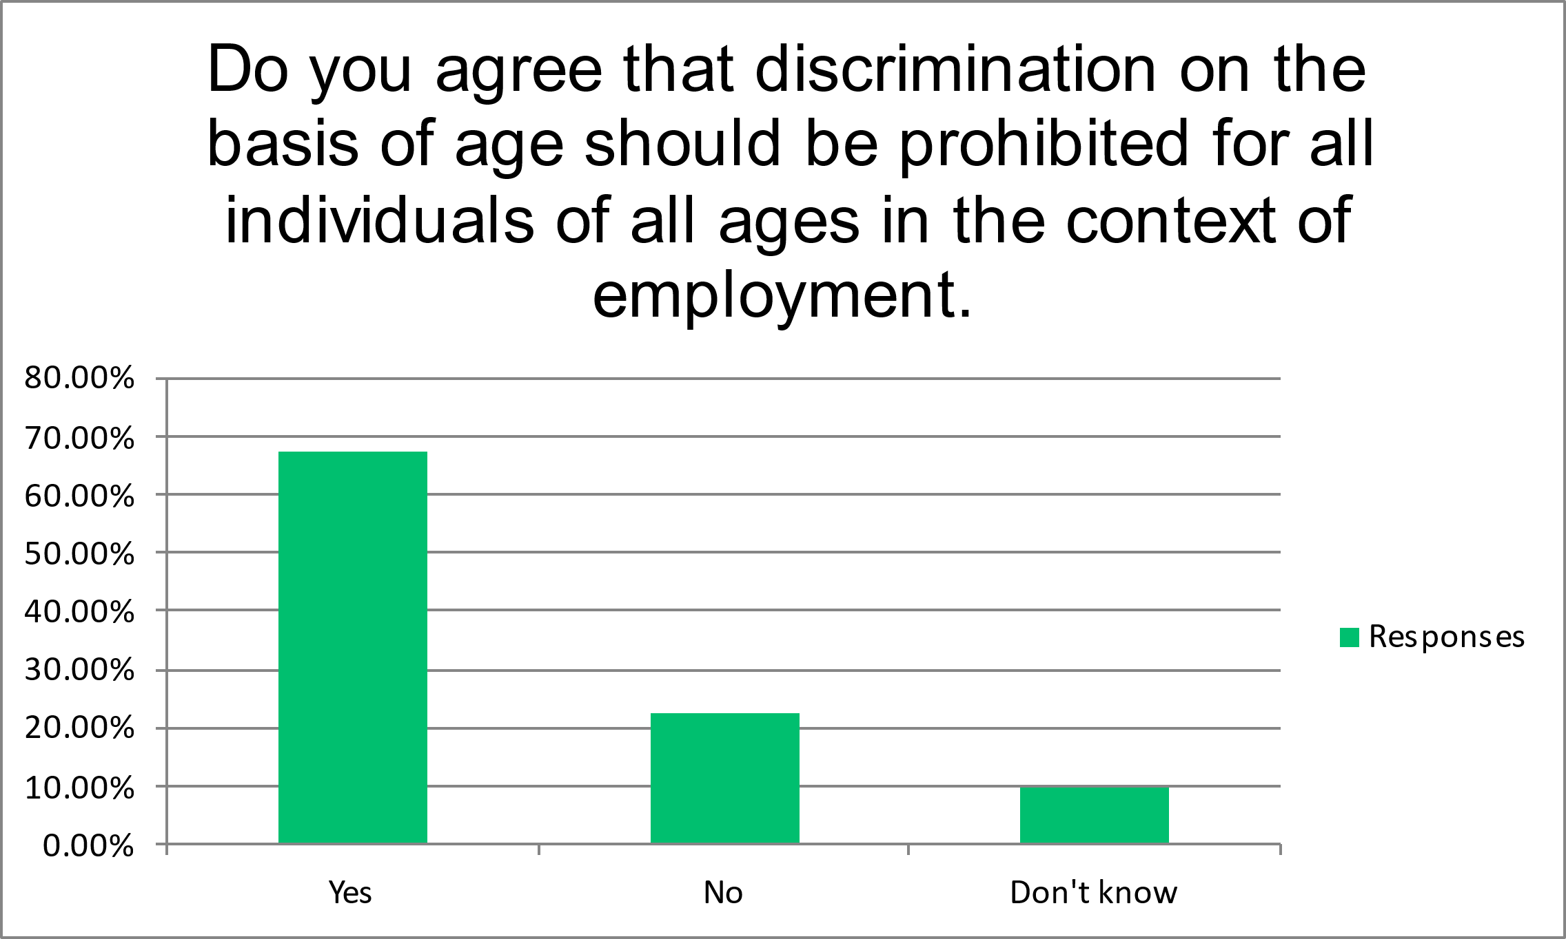

67.50% of respondents agreed that it should be prohibited to discrimination against individuals of all ages in the employment context. However, they also expressed concerns that employers should be able to place reasonable age-related restrictions on employers under the age of 18 and that protection needs to be in place for young individuals to counter safe-guarding issues.

We also asked respondents whether minimum wage should apply to the total remuneration received by 'young persons' (defined as aged 16 and 17) and not just to their basic hourly rate, for example in respect of bonuses paid. 47.50% said no, with the majority of responses focusing on how bonuses should be performance based rather than determined by age, and that bonuses are often not fixed and can be non-cash based such as benefits in kind.

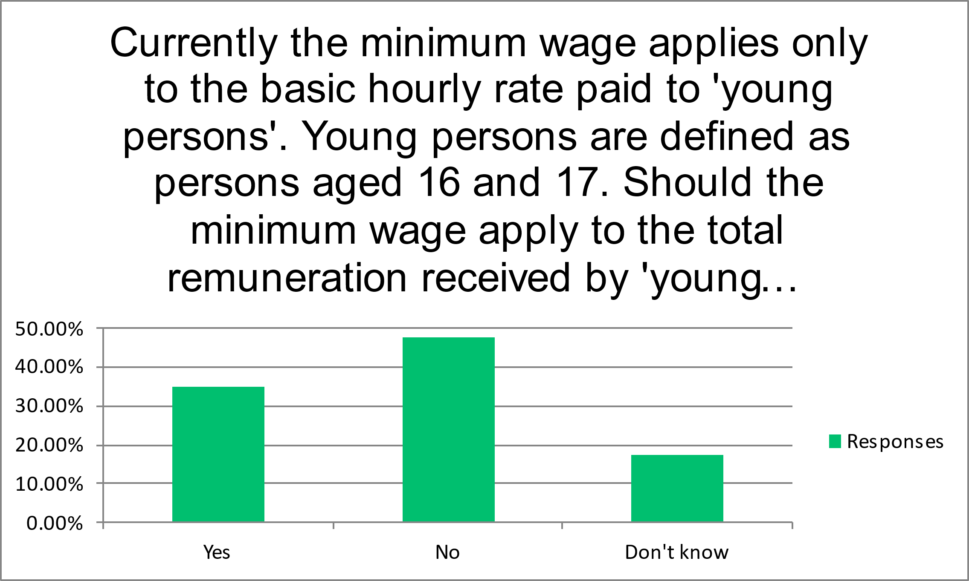

In relation to age discrimination in the workplace, we also asked our respondents some questions regarding organisational benefits. One such question was whether the business provided any benefits to facilitate childcare for its employees, as comparable UK legislation specifically provides that such would be exempt from age discrimination. 93% of respondents answered no to this question, and the majority of written responses focused on having workplace flexibility around working hours and location instead. This suggests that flexibility is available to all, regardless of age.

Our respondents were asked whether their organisation has a formal redundancy policy and, if so, whether it provides severance payments. Only 23.26% answered yes to both, and we then asked whether length of service is used to calculate severance payments and under what rationale. The responses were mixed but showed that a few businesses used length of service, although one mentioned this was capped at 20 years, whilst others used other bases for calculation. The ability to give employees different redundancy payments so long as they are calculated using the same formula, without it being age discrimination, is consistent with legislation in the comparative jurisdictions.

- The Committee's agreed position is that the legislation would not provide protection from age discrimination for individuals in nursery, preschool, primary or secondary education. In these contexts, it is common for different ages to be educated separately and for provision to be targeted at specific age groups. Do you agree or disagree with this position?

Over half of the respondents agreed with this position although it is worth noting that 23% said that the did not know, and 11 respondents skipped the question. Whilst still important within the sphere of age discrimination legislation, it is possible that the respondents found this question to be the least applicable to their situation in responding in a business context. However, as it would be consistent with the position within the legislation in the UK, Jersey, Ireland and Australia, we would expect that many businesses would be in favour of this position.

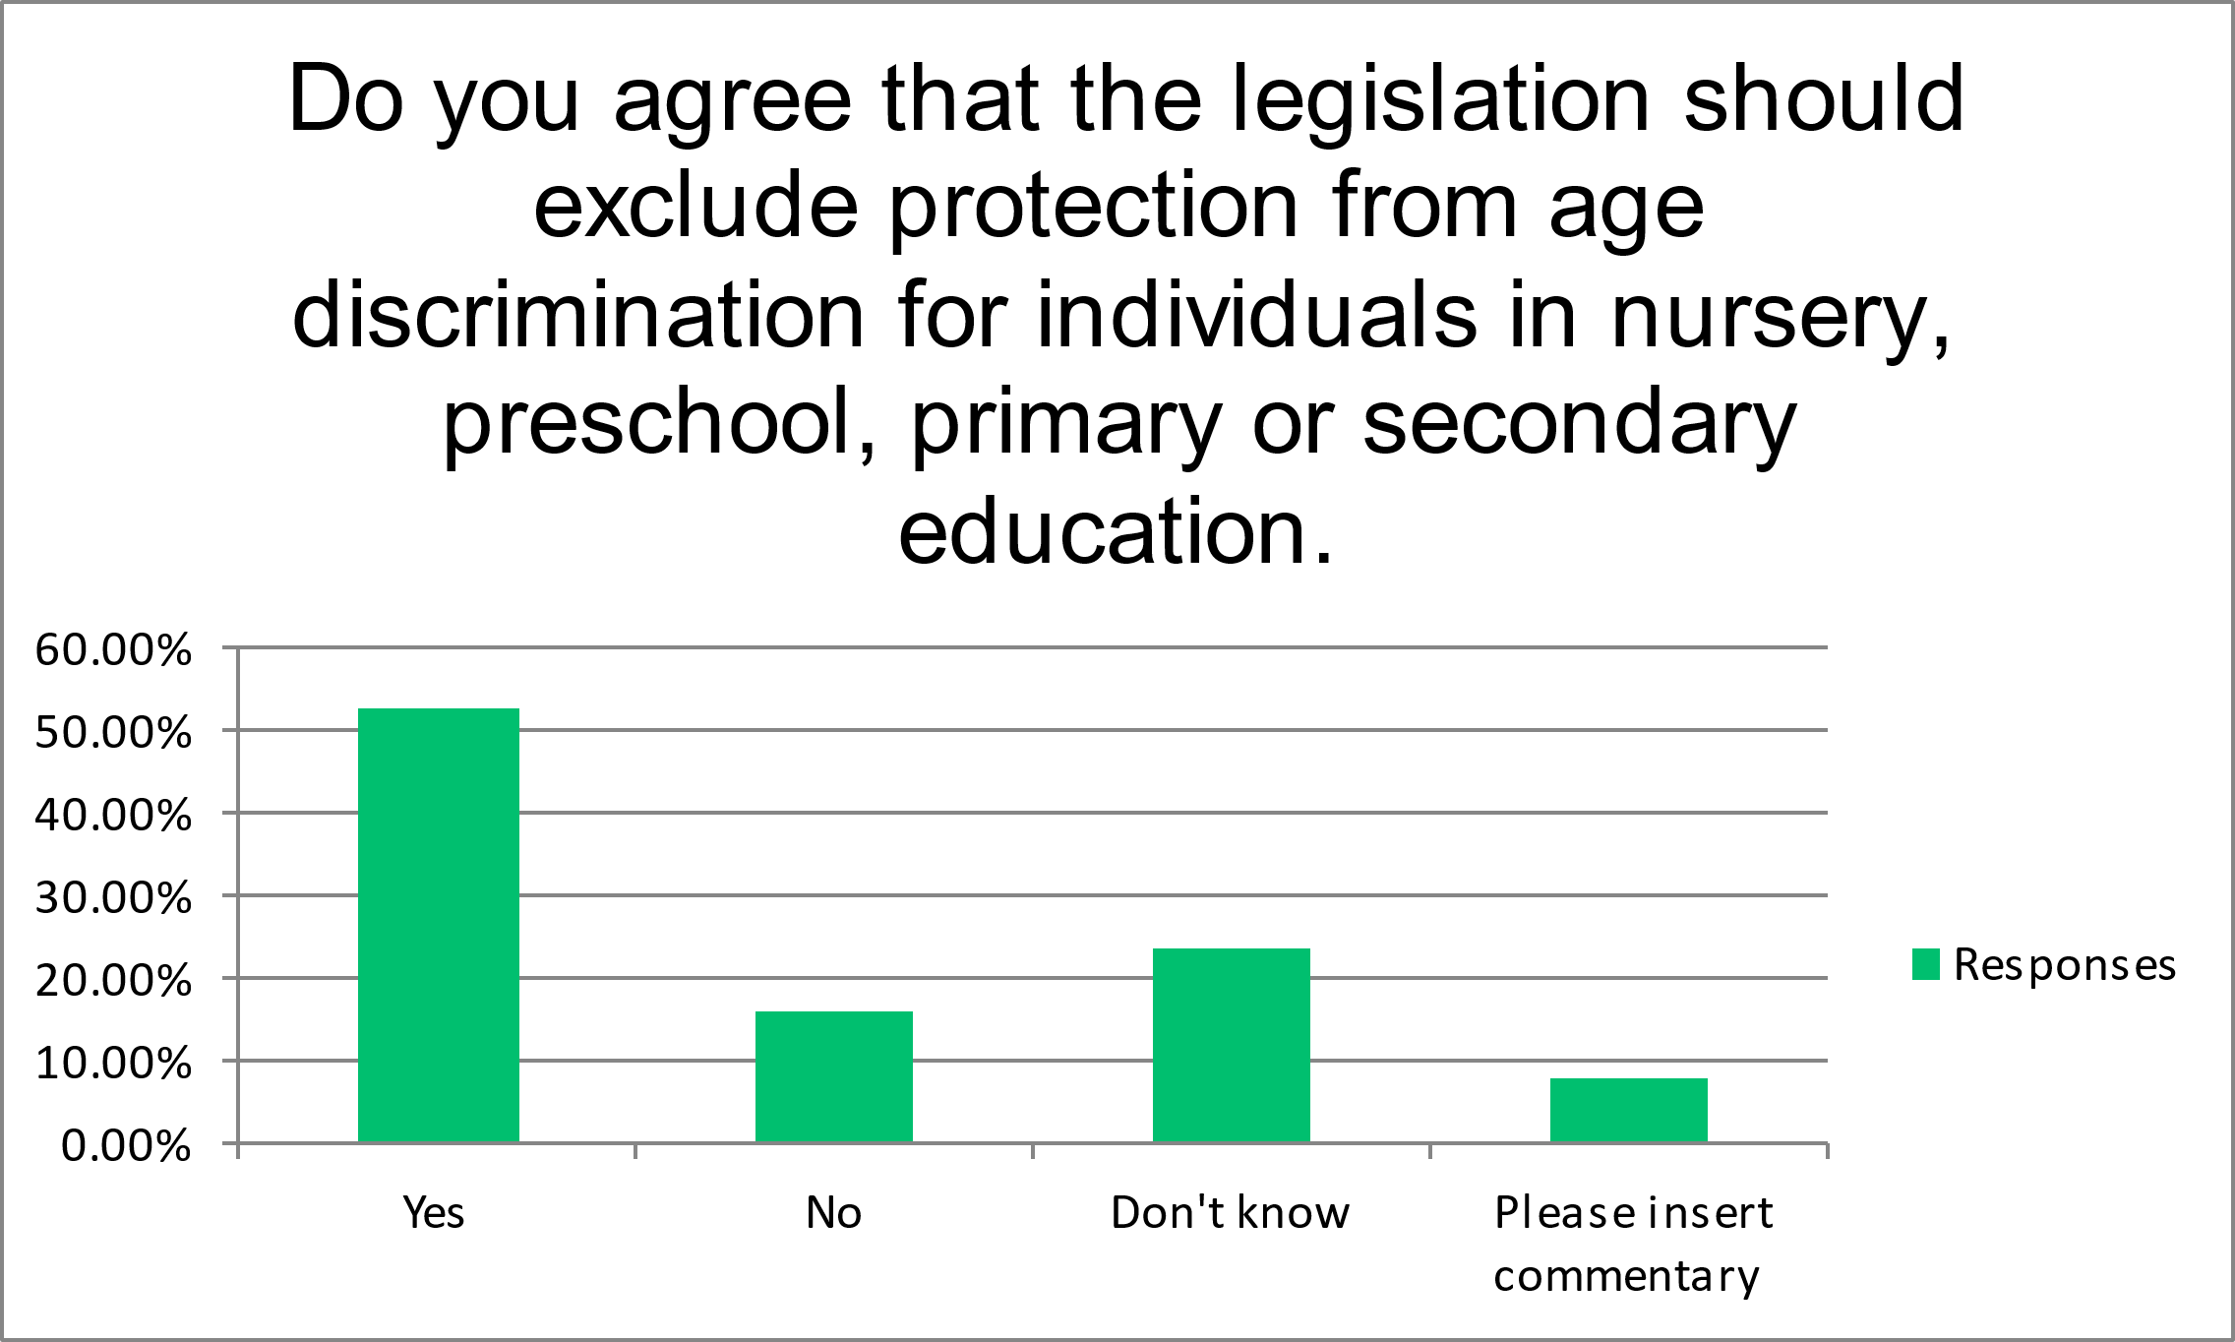

- The Committee's agreed position is that the legislation would not provide protection from age discrimination for individuals under the age of 18 in the context of accommodation provision, the provision of goods and services, and membership of clubs and associations. Do you agree or disagree with this position?

35.90% of respondents disagreed with this in an accommodation context and commentators highlighted that care needs to be taken in this area to avoid exacerbating the current housing issues. There was some support in the comments that age discrimination could be allowed if the accommodation is specifically for young or vulnerable people. There was significant commentary about the need for more legislation around private rentals generally.

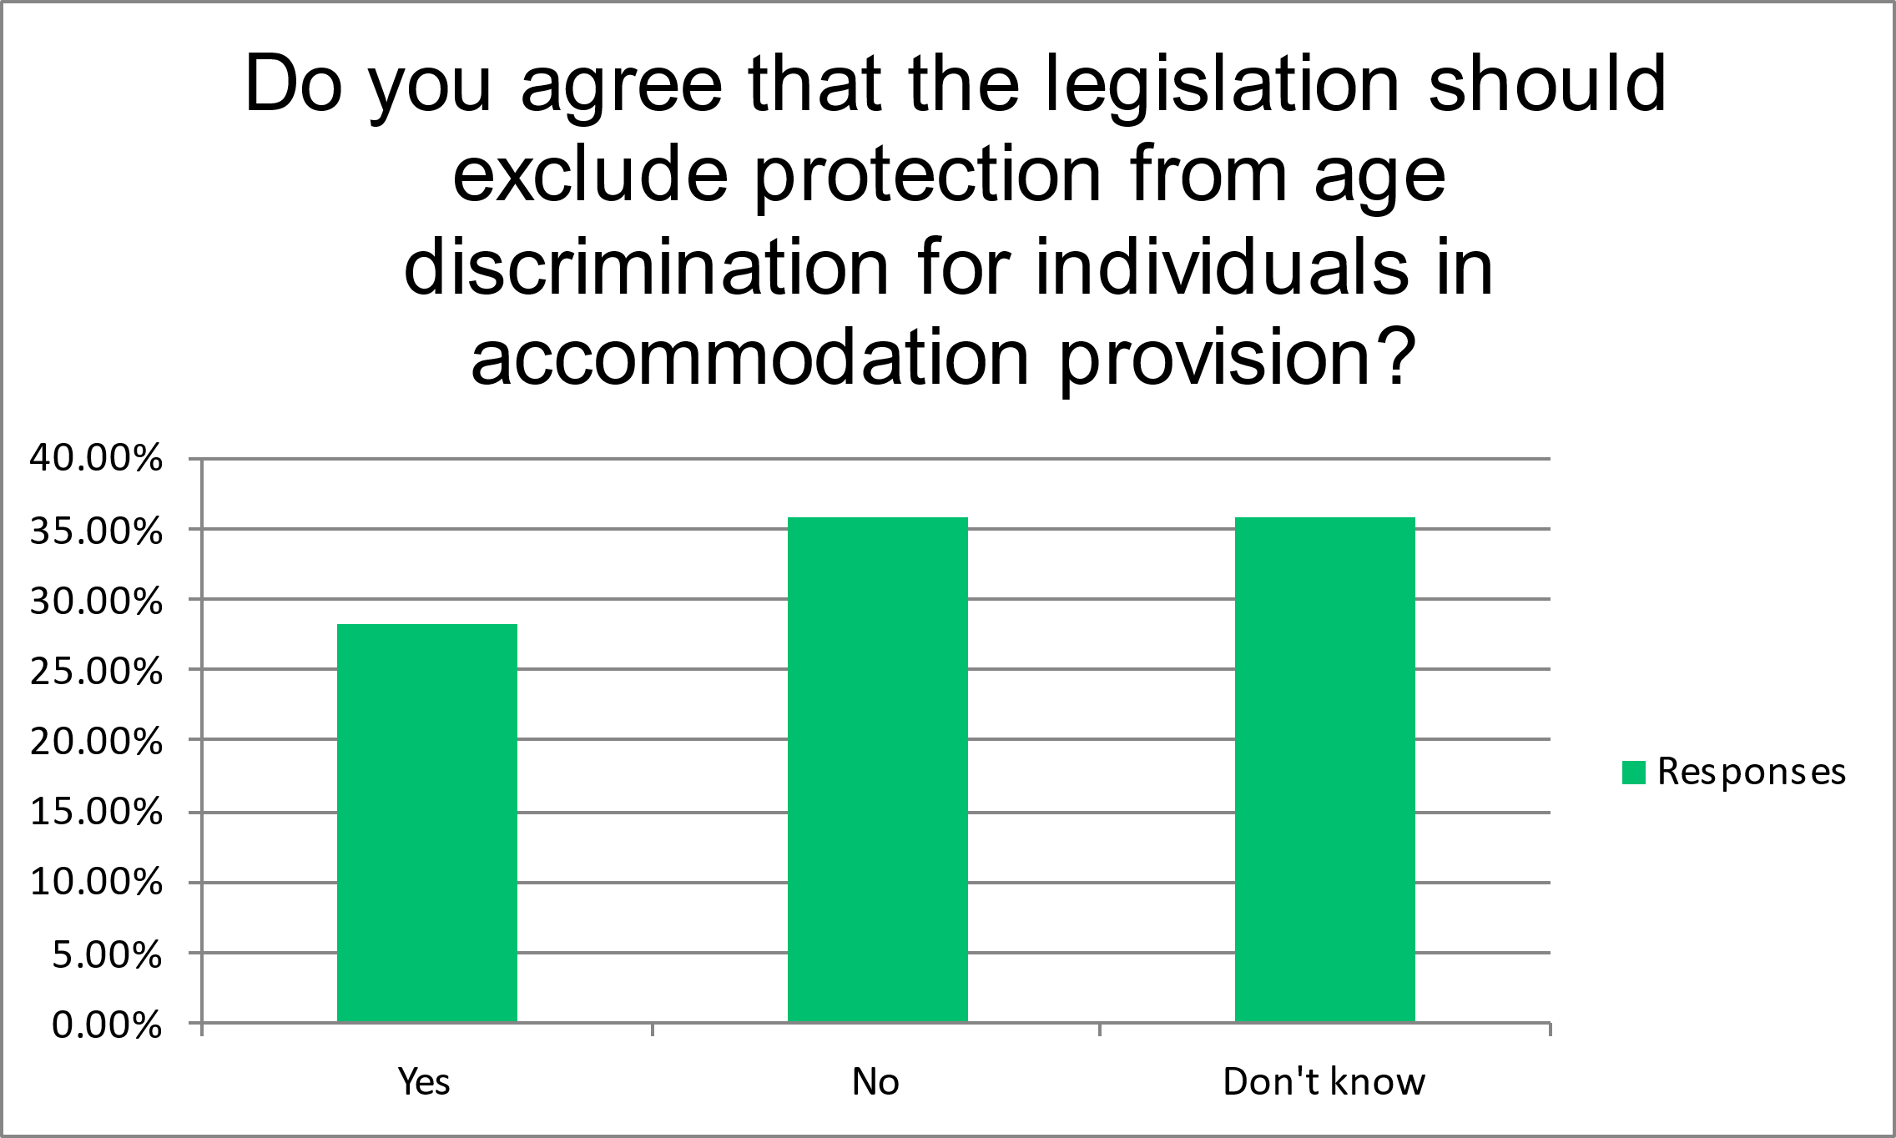

With regards to the provision of goods and services, 41.03% agreed that the legislation should exclude protection from age discrimination for individuals, with 30% disagreeing and 28% not having a view.

On the question of allowing the legislation to exclude protection from age discrimination regarding club and association membership, the response was fairly split as shown in the below graph. Several commentators mention that it should be included if alcohol is served on the premises.

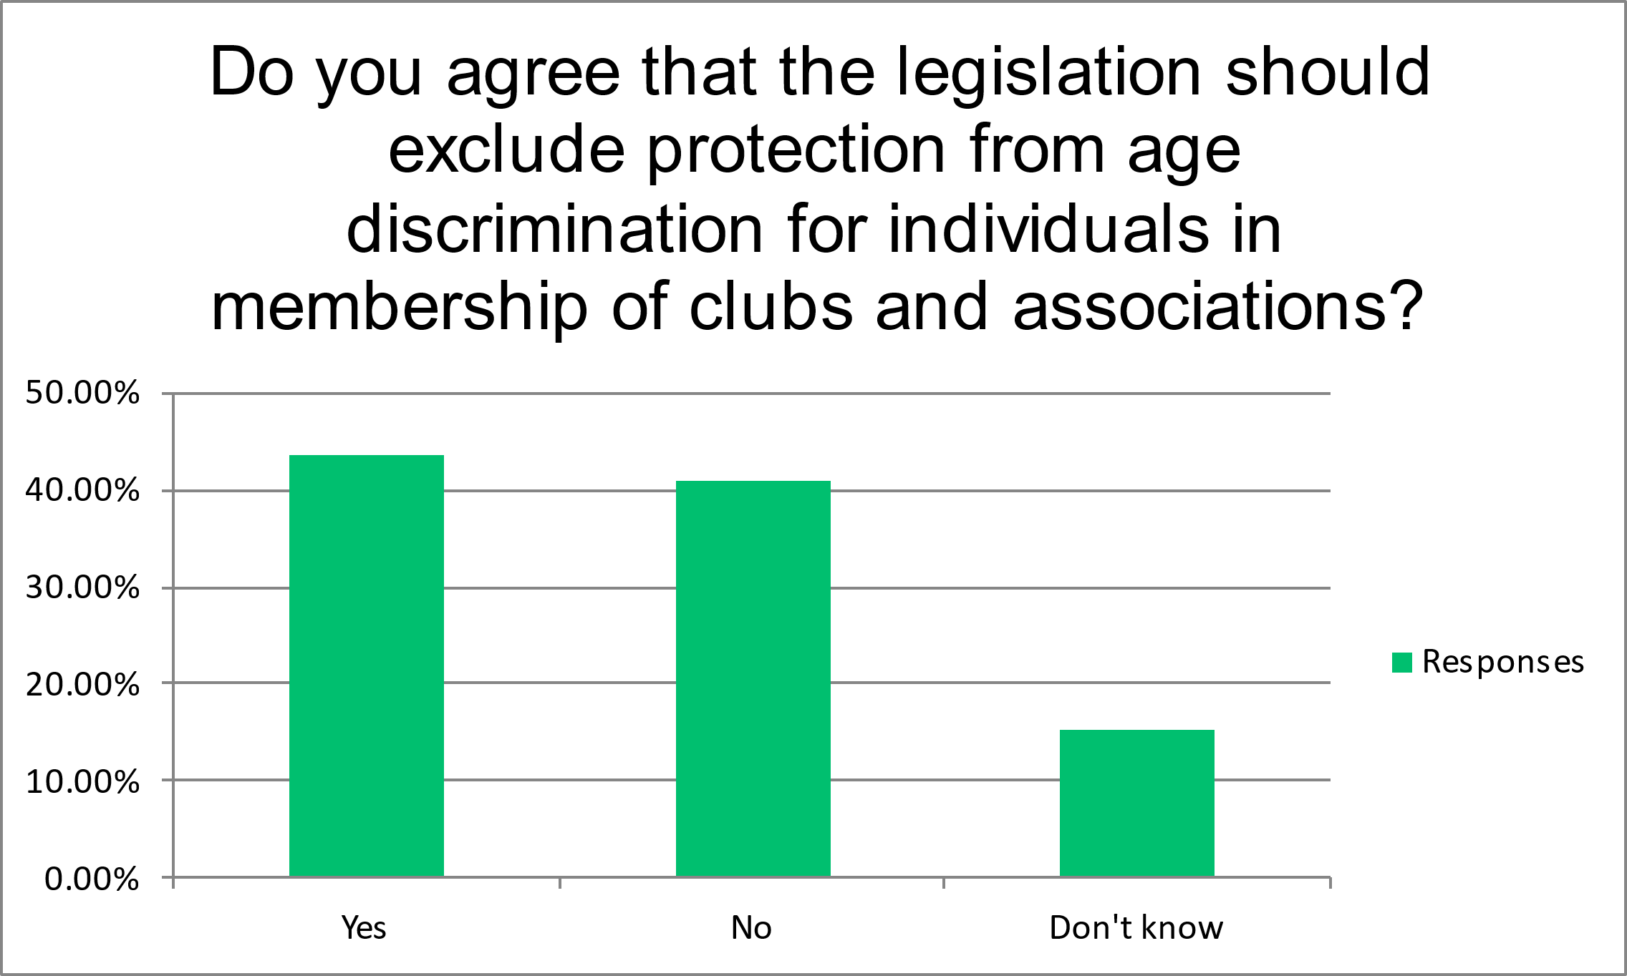

Additional Questions

In addition to the formal consultation questions, we also asked our members some questions regarding protections for young people, combined with some additional questions in relation to the Equal Employment Opportunities Service.

We asked our members about their interaction with the EEOS to date. There was limited engagement with EEOS reported by respondents, with most stating they had no experience with discrimination claims, enquiries, or concerns.

Save for one respondent whose experience with the EEOS resulted in wrong advice being received, those who have engaged with the service found it to be positive, particularly when seeking advice, but there remains a need for better awareness and education about EEOS and its functions among businesses.

In conclusion, the Chamber of Commerce appreciates the Committee's effort in seeking our members' opinions through this process and remain committed to collaborating with the government in any way we can to facilitate the implementation of policies and initiatives that will benefit our members and the wider business community.
Thank you for your attention to this matter, and if we can support further please get in touch.

Yours sincerely,

Stephen Rouxel
President, Chamber of Commerce

